**User Manual**

This documents outlines the user manual for the students and the gamekeepers. This is Version 2 (most recent as of 12/03/2020), as it will be updated when new features are introduced.

**Website:** <https://treasure-hunt-groupb.herokuapp.com/>

**Gamekeeper:**

**Signing In:**

* To sign in, click on “Admin Login” at the top navigation bar
* From here you can log in with your details
* *For the first gamekeeper signing in, please sign in with the details given to you*

**Registering New Keepers:**

* Once you have signed in, you can register new keepers
* Click on the “Register New Admin” option and allow the keeper to enter their details

**Change Your Password:**

* Once you have signed in, you can change your password
* Click on the “Change Password” option and enter your new password
* *If you cannot remember your password details, please email your assigned developer for a reset of your account*

**Track Leaderboard:**

* Once you have signed in, you can see the Leaderboard of the current game right now
* You can view all of the teams of your game; with the number of letters they have and the amount of time they are currently on

**Create New Game/Print QR Codes:**

* Once you have signed in, you can create a new game and print the QR codes for that subject game
* Click on the “Manage Existing Configs” option
* You can upload a new config file for the subject, create a new game or print the QR codes from here

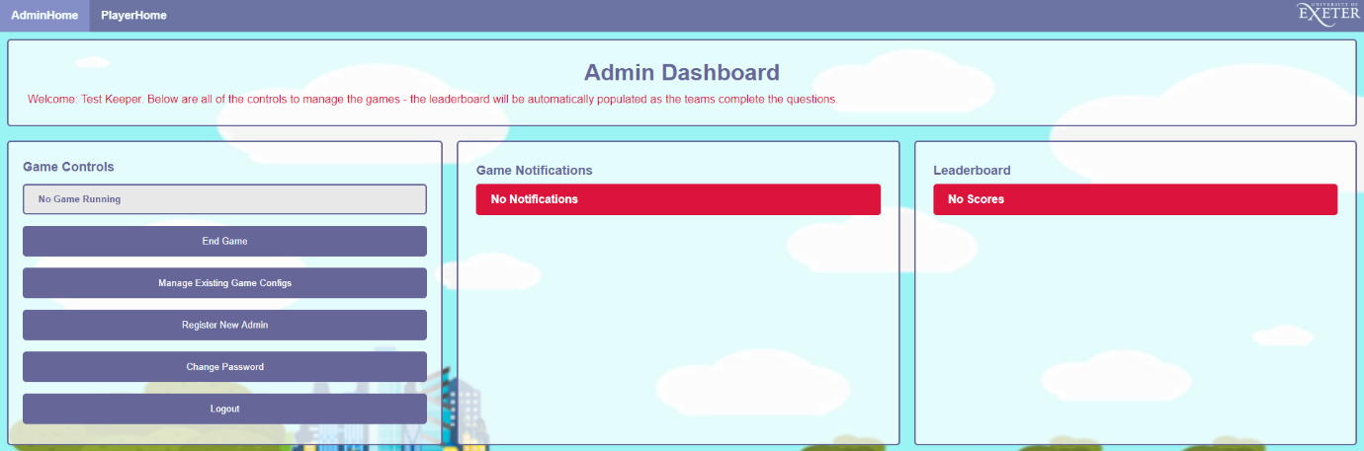

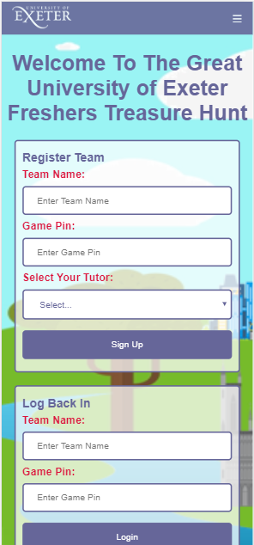**Students:**

**Register Your Team:**

* On the homepage, you will be able to register your team
* Enter your team name, the game pin which your Learning Facilitator has given you, and select your tutor
  + **NOTE:** If you are unable to select any tutors, this is because there is an error with the game pin you entered, please check it to make sure it is correct
  + **NOTE:** Team Name can only contain letters with spaces
* Press signup to register and go to the dashboard

**Access Useful Information and Privacy Policy:**

* You can access useful information, such as lecturer information or FAQs, from the top menu, clicking on “Useful Information”
* You can also access the privacy policy from the same navigation menu

**Logging In:**

* If for whatever reason you were disconnected or left your game, you can resume by entering your team name (exactly how you inputted it) and game pin on the homepage
* You will then be taken back to your dashboard

**Identifying The Locations:**

* 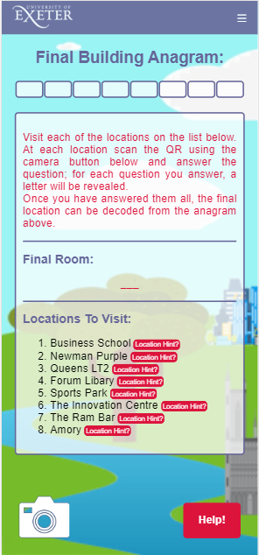On your dashboard, there will be a list of locations
* At each location, there is a QR Code for you to scan (refer to *How To Scan A QR Code* to learn how to do this)

**How To Scan A QR Code:**

* Click the Camera icon on the dashboard page
* Allow the application to access your camera
* Scan the QR code

**Answering A Question:**

* Once you have scanned a QR Code, you will be presented with the question
* Answer the question successfully to obtain a letter to fill one of the Building tiles at the top of the page

**Accessing A Map:**

* There is a map that you can access which has pins for all of the locations
* Click on “Map” on the navigation bar from the dashboard to view this
* Press “Home” to get back to your dashboard

**Accessing The Leaderboards:**

* Click on “Leaderboard” to get to the Leaderboard page from the dashboard
* From here, you can see the progress of your peers and how many letters they have